**Danweyne Estate**

Features/Pages Available on the website-:

1) Index Page -:

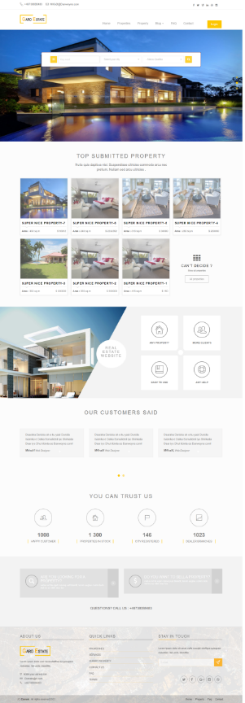

2) Properties Listing Page -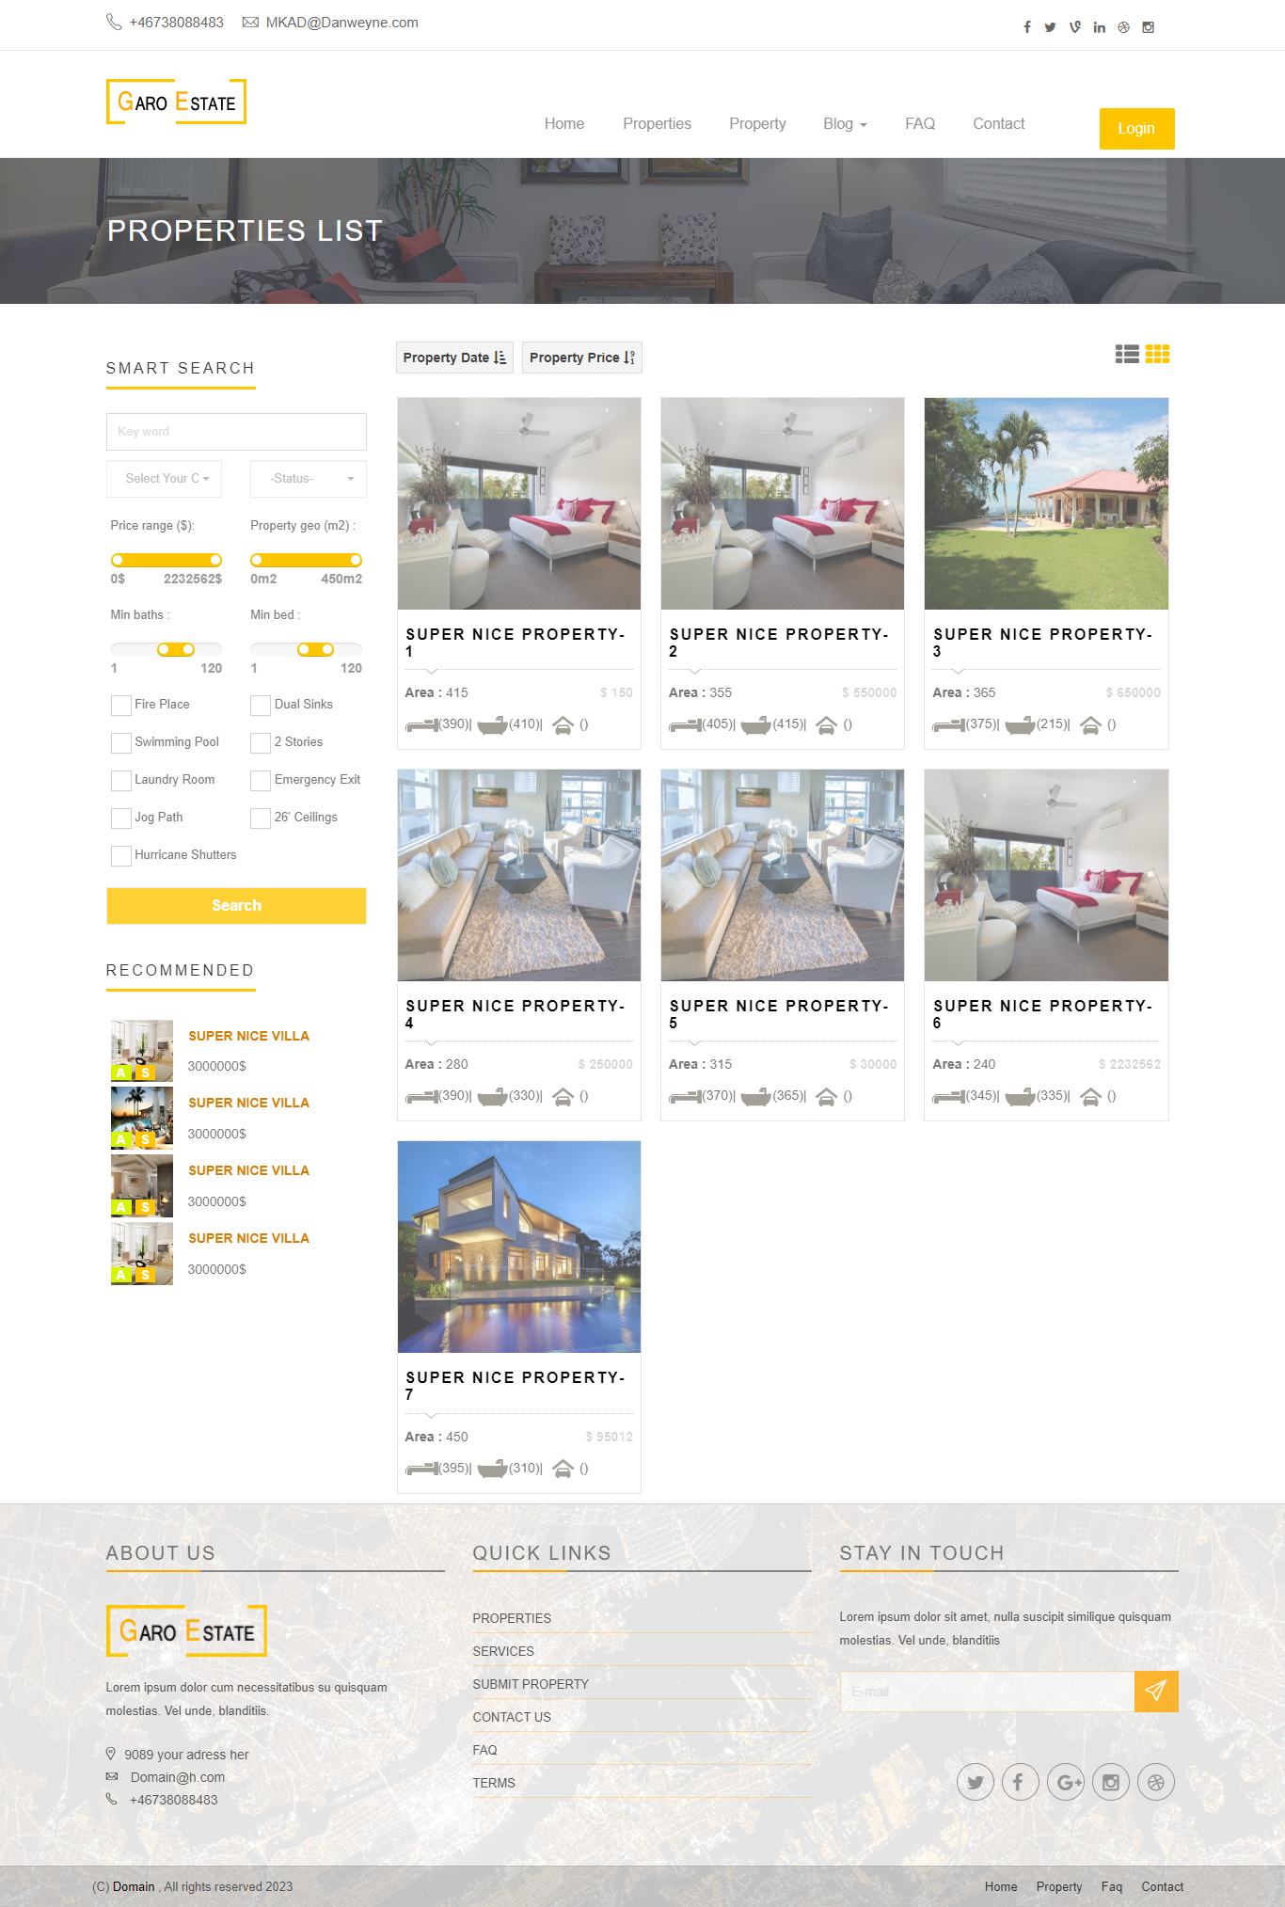:

1. Property Details Page -:

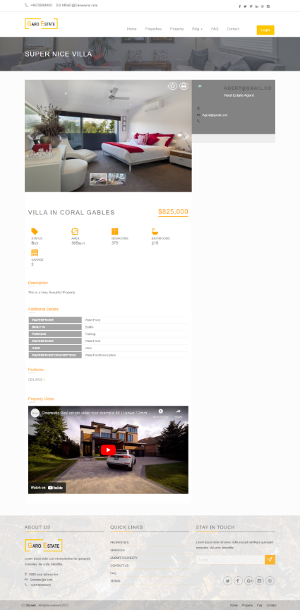

1. Property Insert Wizard Form -:

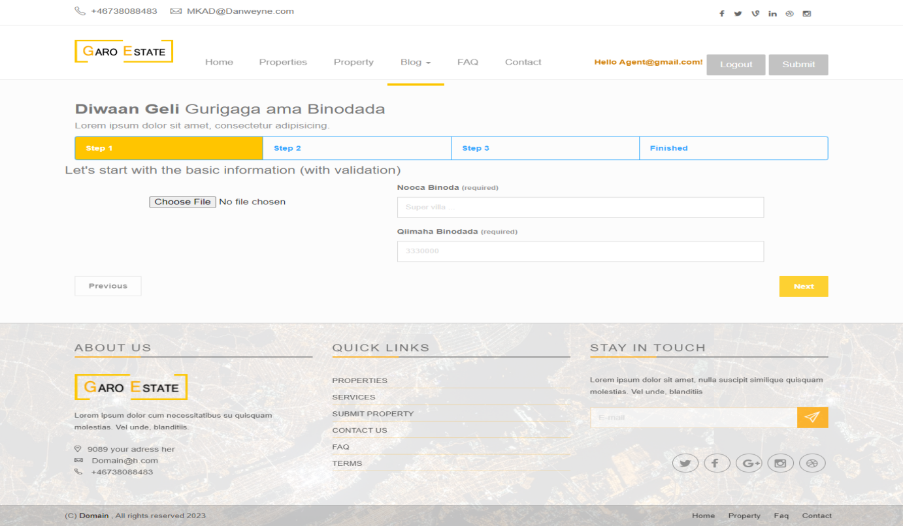

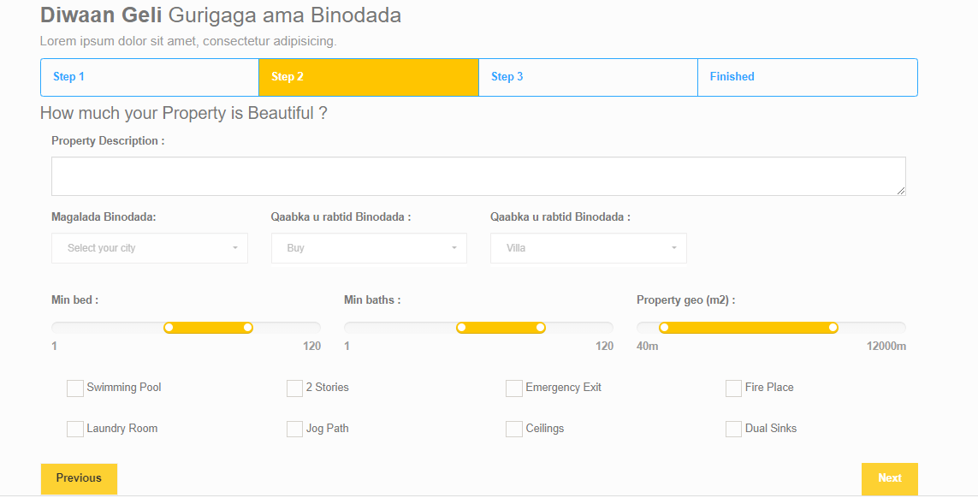

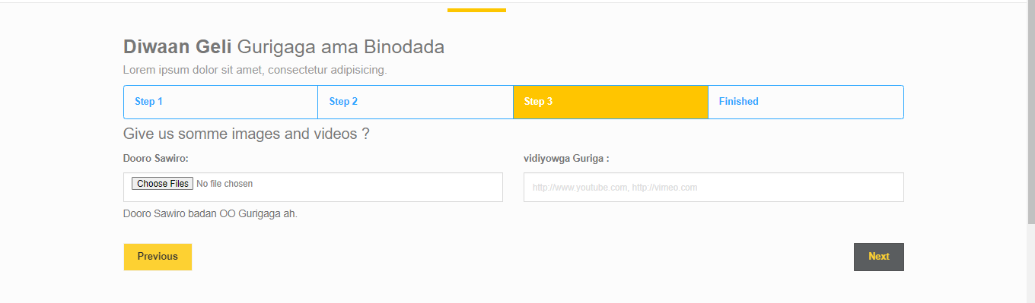

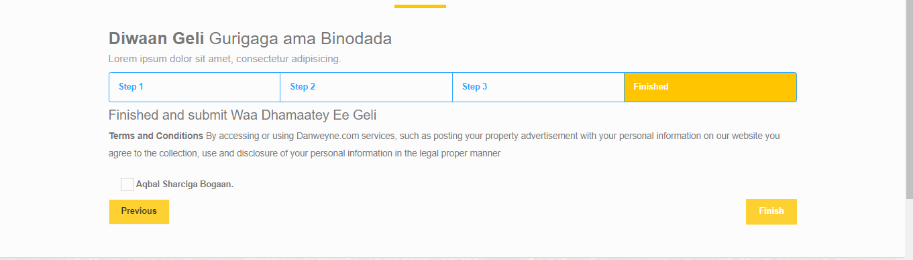

1. Blogs Insert Form -:

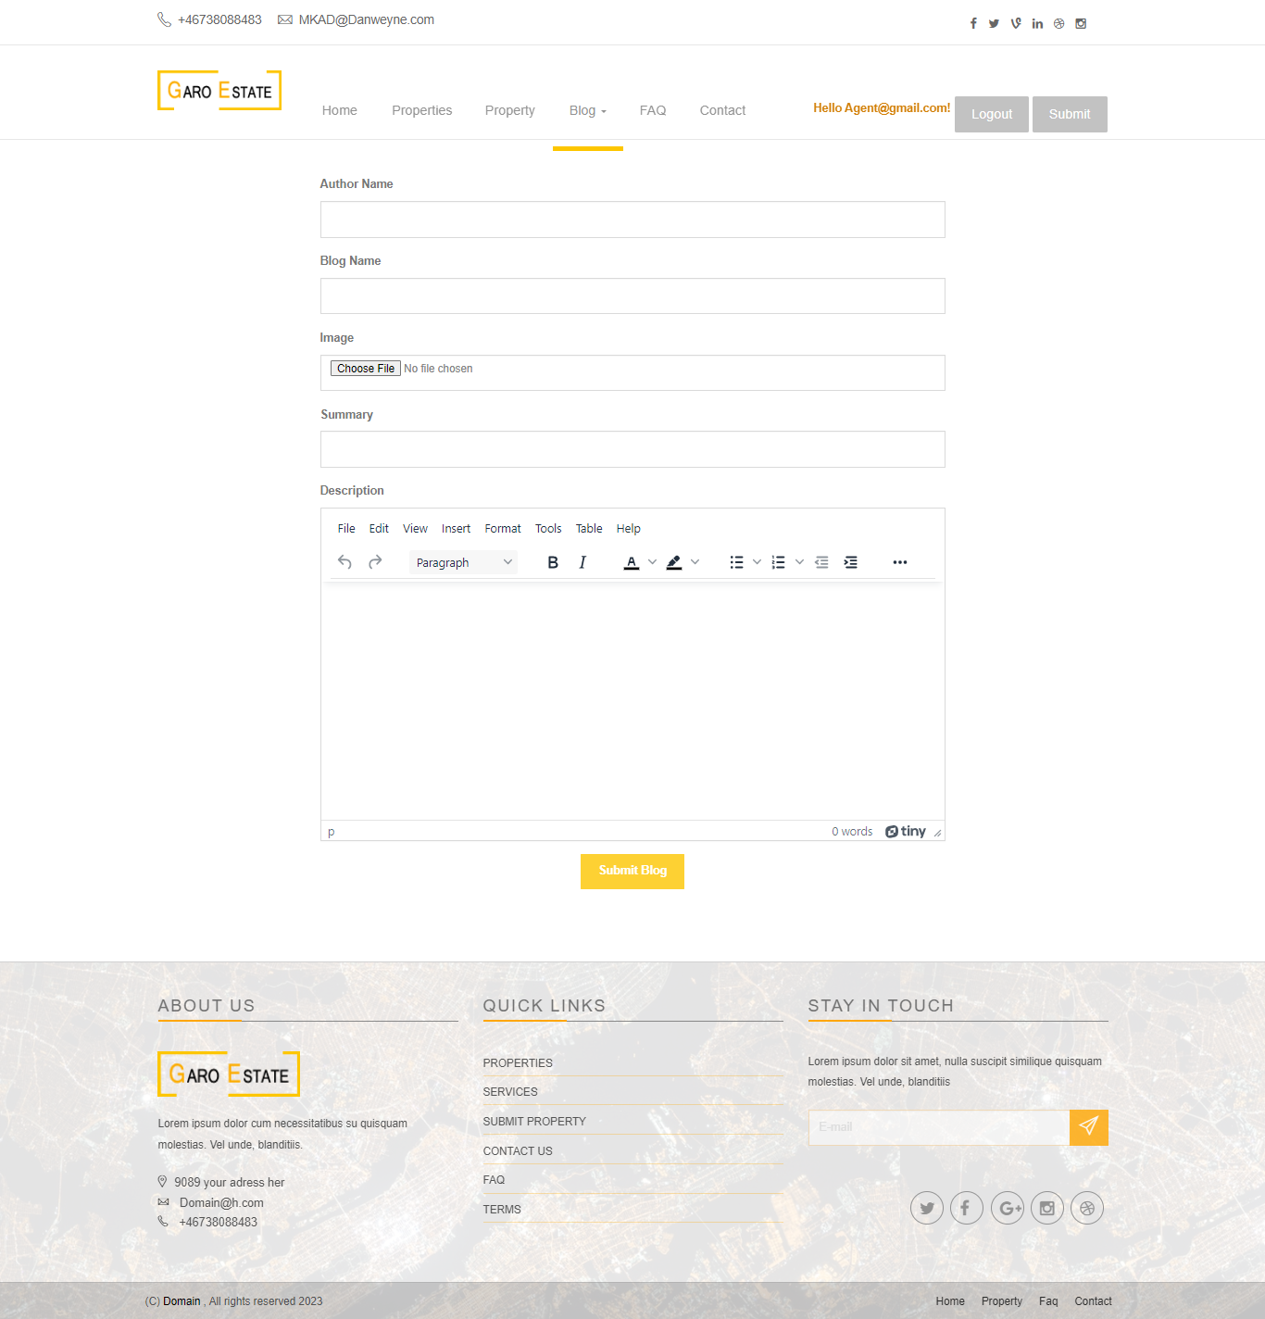

1. Blogs Listing -:

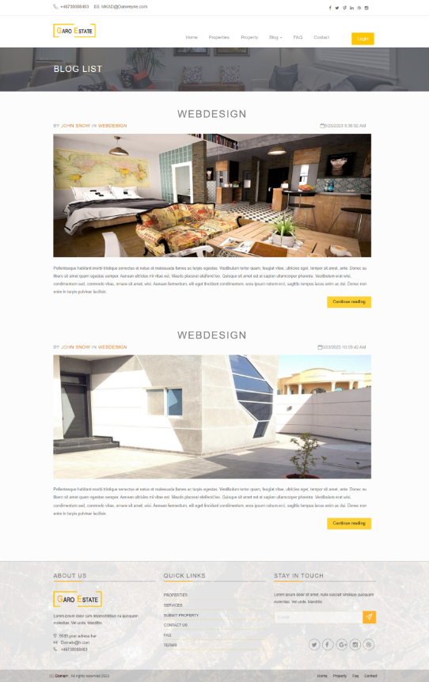

1. Blog Details -:

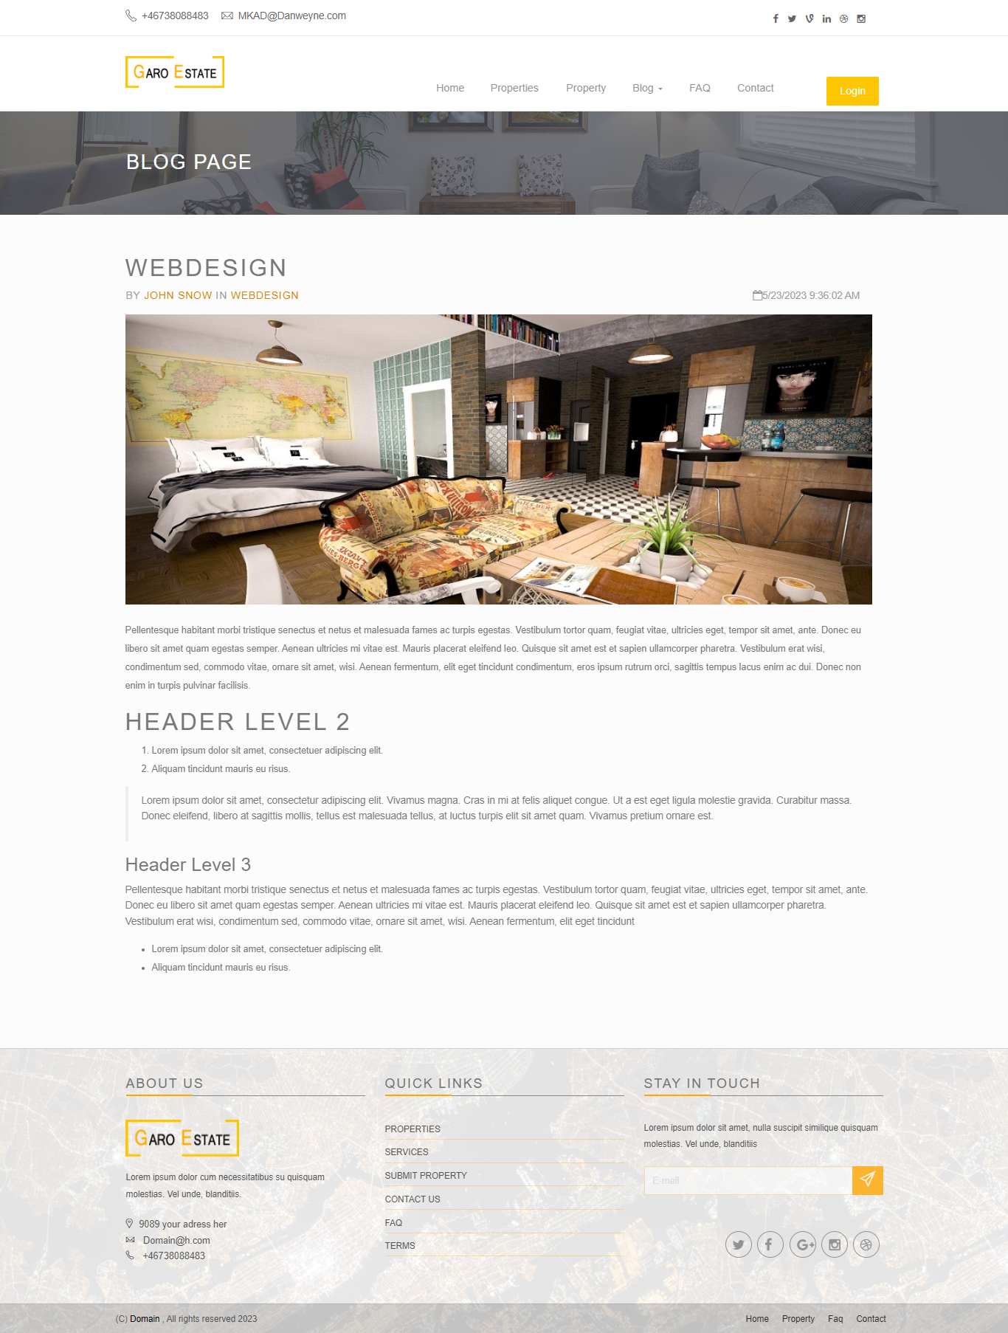

1. FAQ Page -:

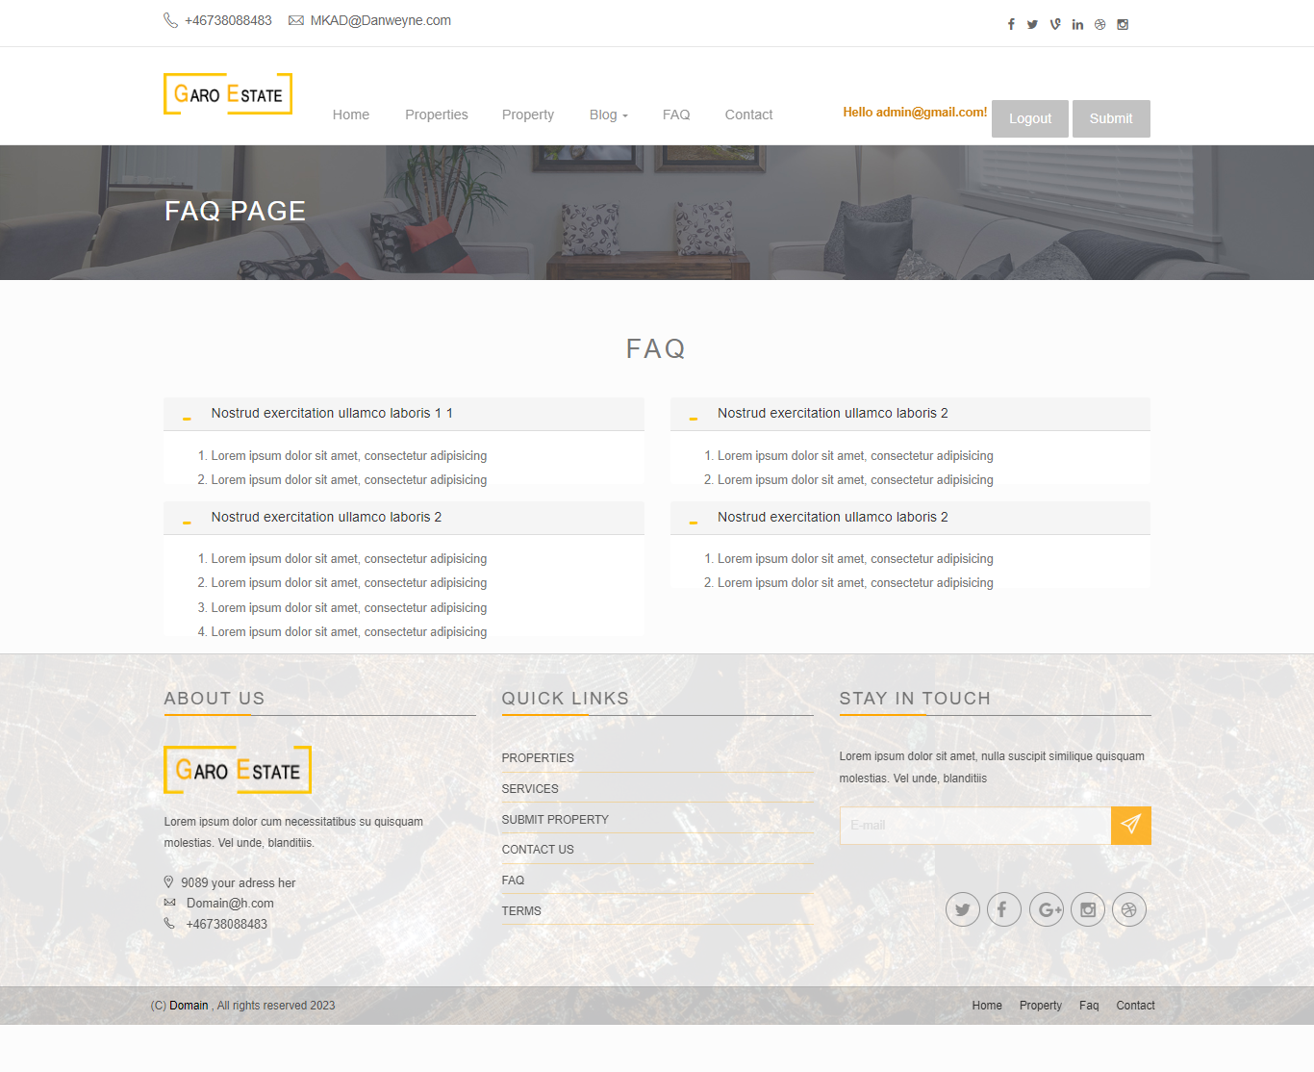

1. Contact Page with Enquiry Form -:

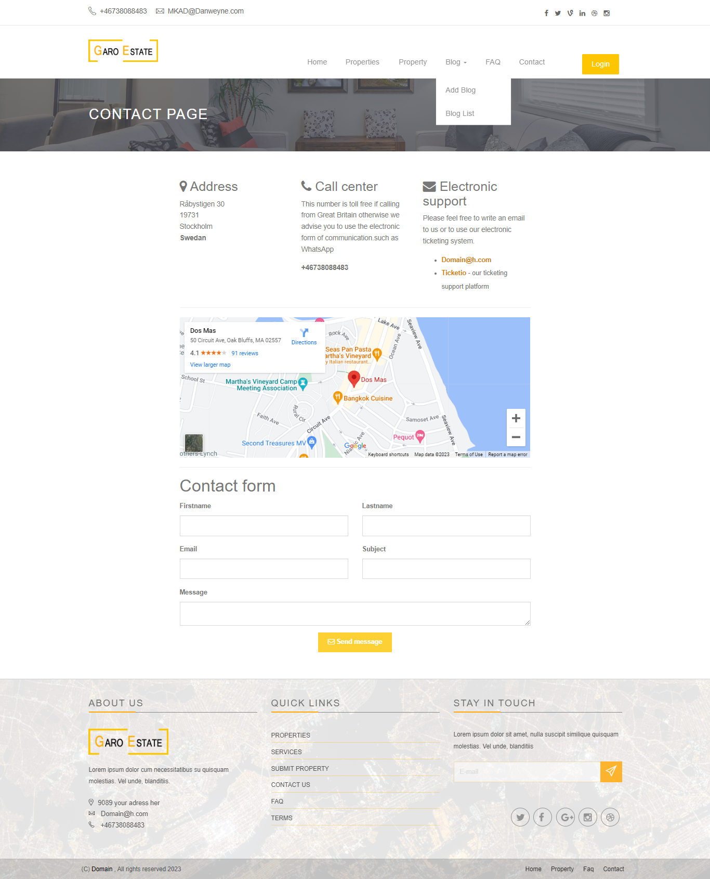

1. Login/Register Page with Additional Role Permission for Admin -:

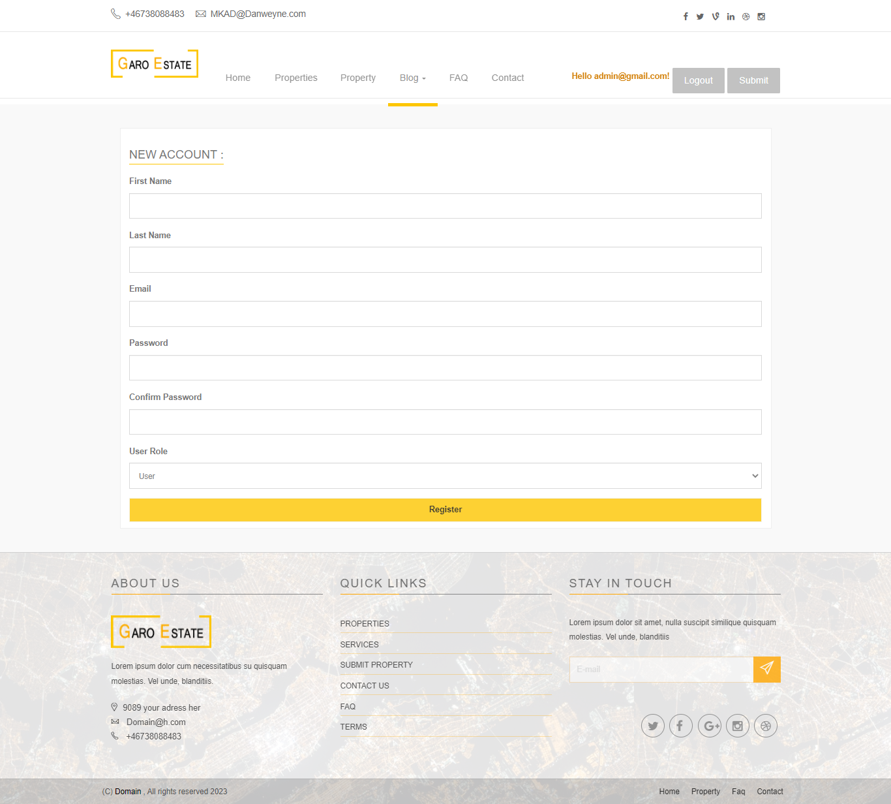

Admin Register Form

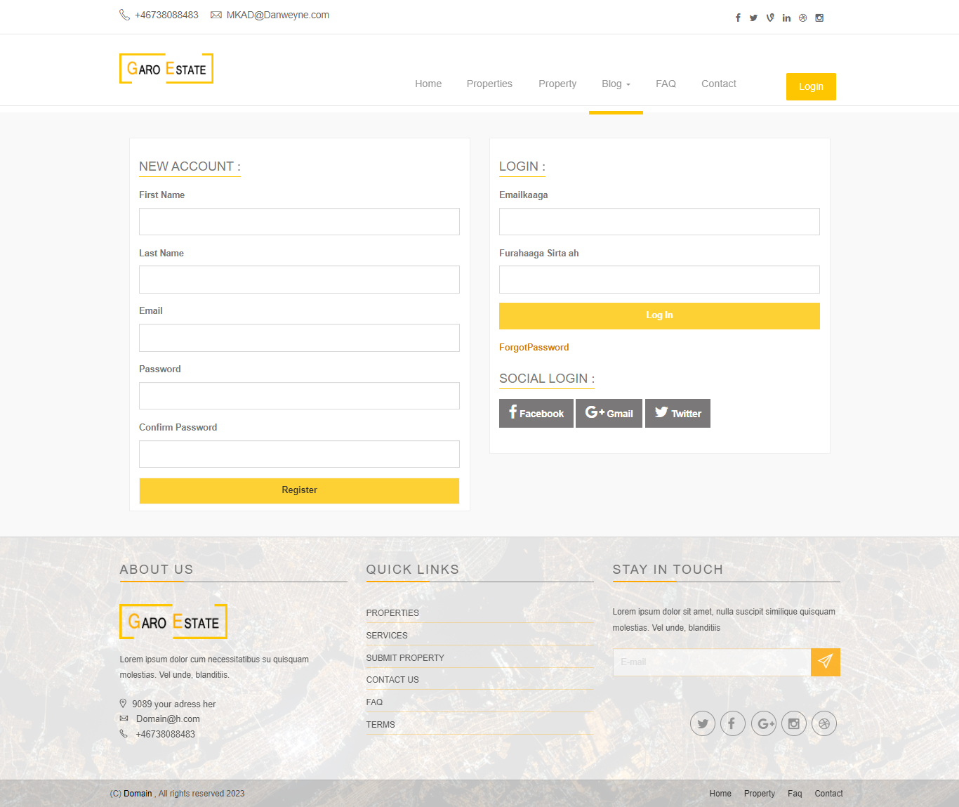

User registration form

1. Change Password -:
2. Forgot Password -:

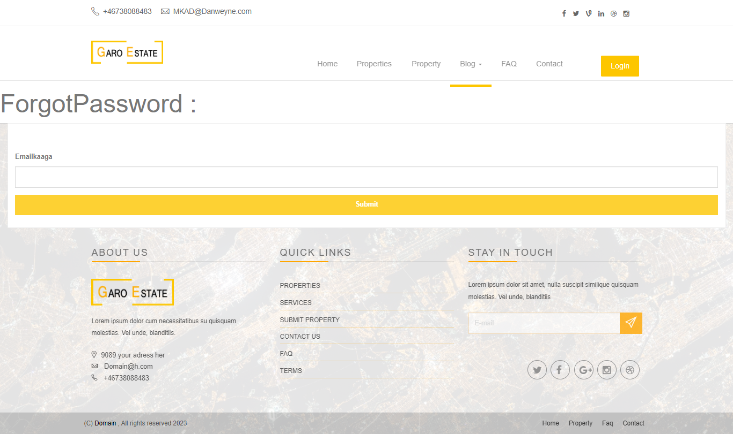

1. Reset Password Page-:

12) Users List Page -:

13) Contact Form Enquiries Listing -:

14) Your Profile -:

Future Features -:

1) MLS real estate listings + IDX.

2) Meeting scheduling feature.

3) Client reviews.

4) Live chat-bot

5) Payment Systems